Alyssa Semerdjian

Stat 510

5 Feb 2018

Homework 3

1.

a)

> area.f=function(r){

+ area=pi*r^2

+ return(round(area,digits=2))

+ }

> area.f(c(2,4,6))

[1] 12.57 50.27 113.10

b)

> f.to.c=function(f){

+ conversion=(5/9)*(f-32)

+ return(round(conversion,digits = 2))

+ }

> f.to.c(c(32,60,90,110,212))

[1] 0.00 15.56 32.22 43.33 100.00

2.

a) a is the limit of growth. For example, when a is 3, the growth line will approach 3 but will not cross it.

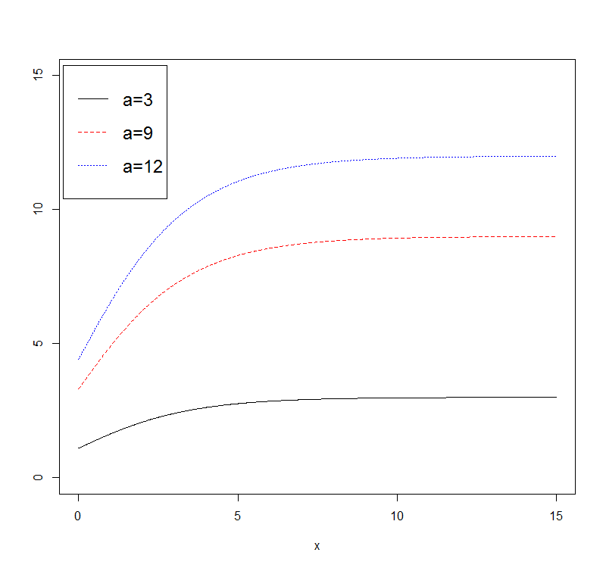

b) Parameter k controls how fast the growth curve approaches the limit.

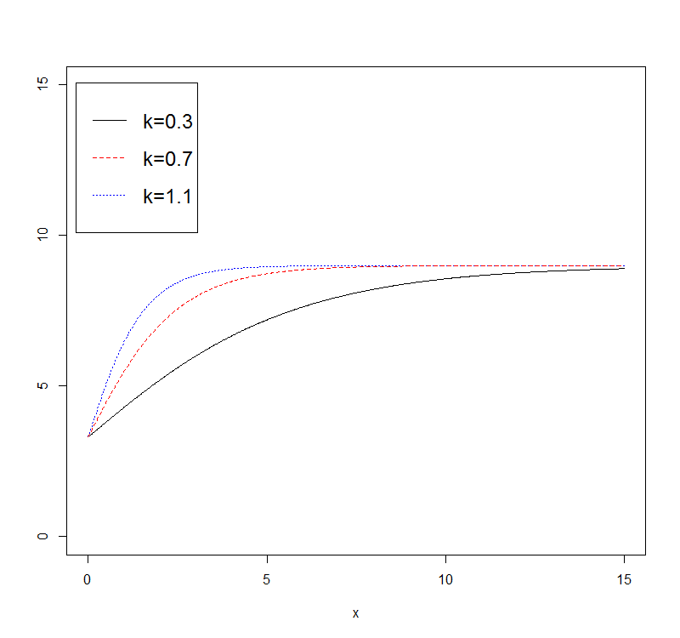

c)Parameter x0 controls where the plot lies horizontally.

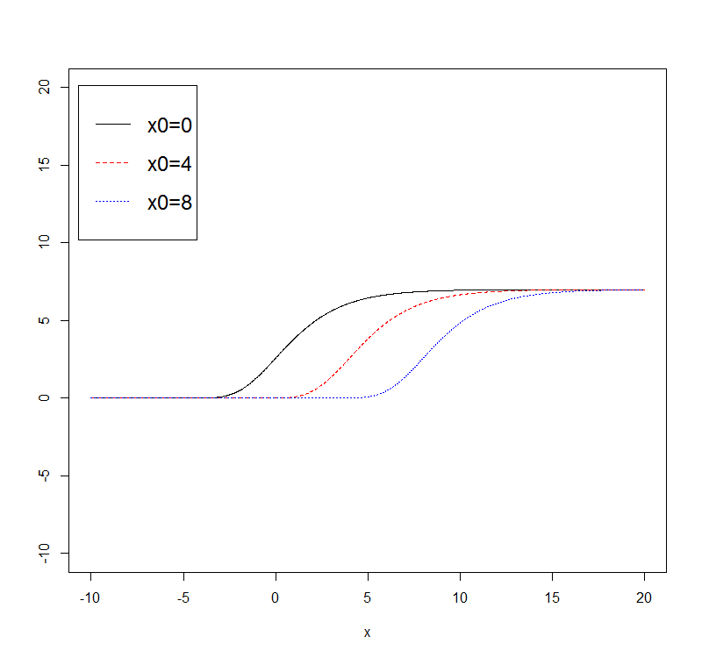

d)

i)

vonb=function(a,k,t0,t){

y=a*(1-exp(-k*(t-t0)))

return(y)}

t=seq(0,10,0.02)

a=c(5,5,5)

k=c(0.3,0.7,1.1)

t0=c(0,0,0)

nam1=paste0("a.",a[1]," k.",k[1]," t0_",t0[1])

nam2=paste0("a.",a[2]," k.",k[2]," t0_",t0[2])

nam3=paste0("a.",a[3]," k.",k[3]," t0_",t0[3])

b=vonb(a[1],k[1],t0[1],x)

c=vonb(a[2],k[2],t0[2],x)

d=vonb(a[3],k[3],t0[3],x)

plot(x,b,ylab="",type="l",lty=1,ylim=c(0,6))

lines(x,c,ylab="",type="l",lty=2,col=2)

lines(x,d,ylab="",type = "l",lty=3,col=4)

legend(locator(1),lty=c(1,2,3),col=c(1,2,4),c(nam1,nam2,nam3),cex=.75)

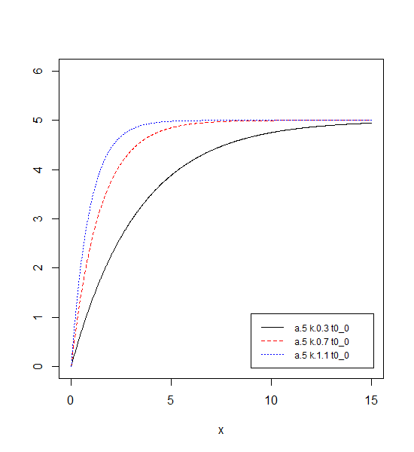

ii) In answer to parts one, two and four: parameter k determines how quickly the growth curve will approach the limit, with the highest value for k having the steepest curve. When k is 0 the lines lie flat on the x axis.

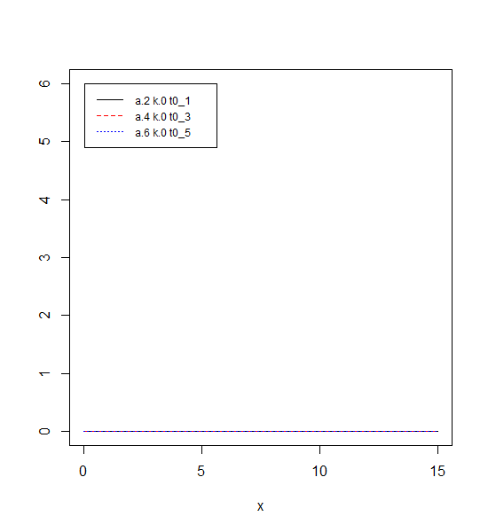

iii) The parameter ‘a’ represents the limits of the lines. The lines will approach ‘a’ but will not pass it.

